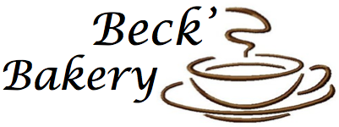

Emma Craig, Kaitlyn Click, Becca Coats, Casey Collins
KNH 303
Fall 2014

Prospectus

Rationale

Beck’s Bakery is a modern, fresh take on hearty and wholesome food in the Oxford area. By putting a premium on using local, fresh ingredients, Beck’s Bakery offers the best possible food to customers while also stimulating local business in the area. We are more than just a standard coffee shop; our menu is contemporary and and different than other Oxford businesses of similar niches.We started this business because we found there to be a lack of restaurants in Oxford that provided customers with local foods. Because Oxford is surrounded by rural areas, we want to take advantage of the local resources and farms that other cities may not have in order to bring only the highest quality foods to our customers. We will be purchasing all of our produce locally at Butterfield Farms and all meat and poultry will be ethically obtained and hormone free.

Physical Operational

Our bakery will be about 2000 square feet total, with 900 square feet dedicated to the kitchen. We have the capability of serving 70 people at a time, with plenty of table and sitting space for students to study and relax with a coffee and a good meal. We stress serving only the highest quality ingredients and we will be making sauces such as mayo, pesto, and salad dressings ourselves in our kitchen. Our kitchen workers will be baking the pastries fresh every morning, along with cooking the signature meals each day. The employees we hire will vary in age, education, and experience. In our operation, there will be opportunities for both full and part time workers ranging from manager positions to part time cashiers. This will allow students to pick up a part time job while taking classes or during the summer, along with full time kitchen managers to take on more responsibility and hours in an exciting, new business. Because we are only open in the mornings, we anticipate a high volume of business from people going to work and class. Our meals will be prepared quickly for people on the go, but there is also a spacious, welcoming atmosphere for people who would prefer to have a sit down meal. In the future, we plan to offer catering services for parties and events after we build a dependable reputation amongst Oxford residents.

Regulatory Information

Because we are using fresh, high quality foods, we want to ensure that everything we serve is sanitary and safe as well. All employees handling food will be required to wear gloves, hair nets, aprons, and closed toed shoes. We will also have a plethora of toxin-free surface cleaners to sanitize tables that food is being prepared on. Our kitchen design features a separate area for all dishwashing to occur and we will be checking the temperatures of the storage areas, fridge, and freezer twice daily to ensure they are at the proper temperature. Our kitchen will be insulated to control the noise and also help keep down energy costs from heating and cooling. All employees will go through a thorough orientation to learn how to use any equipment in the kitchen and there will be a kitchen manager present during all shifts. Our appliances will be energy star certified when possible in order to cut down on the energy used in the kitchen.

Regulations

There are a variety of government agencies that will need to be contacted in order to be able to open our bakery. The first is the Internal Revenue Services, who will be contacted as we file our bakery’s taxes as well as our business type. The U.S. Department of Labor will be contacted as well as they manage all persons and laws associated with employment and unemployment. The USDL also makes sure workers are compliant and deals with some aspects of compensation. The Occupational Safety and Health Administration will ensure all safety and health regulations in the workplace are followed. The US Patent and Trademark Registration office will also be contacted in order to register our bakery’s name as a federal trademark. The USDA and FDA will be contacted to deal with all food-related issues that come along with opening a bakery. The Ohio Department of Agriculture requires all pies, cakes and bakery items must be licensed with them.
Locally, we will contact the Butler County Health Department to confirm building plans to gain approval. WIth this, we will need Public Health Zone Permit and Building and Zoning Permit which will allow us for new food service construction. The Butler County Ohio Secretary of State will be contacted in order to register our business’ name. We will also need a Vendor’s License in order to sell our products. We will contact the Ohio Department of Revenue in order to get our Sales Tax License. We will also need a Waste Removal Contract.
It is essential our bakery also has insurance. We will have Fire, Theft, Liability and Water Insurance. We will also offer worker’s compensation insurance. This protects the bakery’s employees as it provides medical care to employees who are on the job.

Timeline

Month | Responsible Party |  | Date Complete
1 | Mgt. Team | Prepare a prospectus (Program Planning Guide)  Include rationale, physical and operational characteristics as well as regulatory information
 |  | Research Financial opportunities, bank loans, grants, public, private funding in Oxford
2 | Mgt. Team Leader | Consult with Butler County Health Department (Ohio Revised Code of Regulation)  Contact USDA, IRS, OHSA, US Patent and Trademark, ODA, Butler County Ohio Secretary of State, Ohio Department of Regulation
 |  | Meet with contractors to develop building plans, kitchen, floor layout and storage facilities (fridge etc.)
3 | Mgt Team | Confirm building or renovation plans with the Butler County Health Department, make any changes necessary  Obtain a Public Health Permit and Building and Zoning Permit to allow for new food service construction
 |  | Finish contract for property
4 | Construction Workers | Basic construction begins, including electric and plumbing fixtures, as well as waste removal contract
 | Mgt. Team | Order equipment  Meet with product vendor, finalize menu, finalize brand and logo, meet with interior designer
5 | Mgt. Team Leader | Obtain Fire, theft, liability and water damage insurance
 | Mgt. Team | Consult with plumbing and fire inspector, revolve handicap issues
6 | Contractor and Sub-contractor | Install approved heating and cooling systems
7 | Contractor and Sub-contractor | Install drywall, flooring, pain
 | Contractor and Sub-contractor | Install new equipment, ensure proper installation and usage
8 | Mgt. Team | Advertise for New Employees
 | Mgt. Team | Interview and Select New employees
9 | Mgt. Team | Train new employees
 | Chef and Mgt. Team | Finish Menu testing
10 | Butler County Health Department | Final inspection by the Butler County Health Department
 | Mgt. Team, Contractor | Make any adjustments
11 |  | Open for Business
12 |  | Grand Opening

LEED Guidelines

Our establishment will do everything possible in order to create the greenest and most sustainable business that we are capable of. After studying the LEED guidelines, we have come up with several ways that Beck’s Bakery will meet the expected standards.
- Eliminate negative impact on local ecosystems: All of our cleaning agents will be environmentally friendly and free of harmful toxins. Additionally, any paint we use on the walls inside or outside our bakery will also be free of environmentally harmful toxins.
- Develop a sustainable site plan: We will be setting up a rooftop herb garden to grow thing such as basil that we will use in some of our recipes. This will be beneficial to our own operation while also benefiting the environment because our garden will help absorb carbon dioxide in the atmosphere. We will also have a bike rack installed outside our storefront to encourage biking instead of driving. Additionally, we will be composting our waste to help create healthy soil and reduce the amount of waste that enters landfills.
- Safeguard water supplies and ensure water use efficiencies: We will have rainwater collection tanks to recycle water to be used for plumbing in the building. We also train everyone to double check that all faucets are turned completely off and that all dishwashers are run at full capacity.
- Determine optimum facility and equipment energy efficiency: Our appliances will all be energy star certified and we will routinely check all equipment to ensure it is working properly to avoid wasting energy. The equipment will only be turned on when necessary. Our space will also be insulated very well to reduce the need for excess heat and cooling.
- Make use of recyclable and recycled materials: We will provide trash and recycling cans inside and outside of the building. We will cut out as many single-use and metal containers as possible and ensure all of our packaging is recyclable. To cut down on waste, we will donate excess foods to the OCCP instead of throwing them away.
- Preserve indoor environmental quality after opening the facility: All lighting inside of Beck’s Bakery will be provided from energy efficient CFL lighting. We will cover pans while they’re heating up and we heat large quantities of food whenever possible as opposed to smaller qualities. Lastly, we will offer customers who bring their own coffee mugs, cups, tumblers, etc a discount on their beverage as incentive to cut down on waste.

Marketing and Advertising

Facebook Page
https://www.facebook.com/cometobecksbakery
This is the facebook page created for our customers. We will invite customers to join our page by asking them their emails when they come the first time. We will post our menu as well as our weekly specials. We will do a promotion such as “Like us on facebook and get $2 off your meal!”

Twitter Account
https://twitter.com/Becks_bakery
This is the twitter page created for our customers. Like our facebook page, we will post our menu and specials of the week. On this twitter page, we will also follow other local businesses as well.

Website
http://becksbakery.weebly.com/
This is the website that will show up when people google our business. It will have the menu, specials, and an about us category. It will also feature pictures and music selection.

Loyalty Cards and Flyers
Loyalty cards will feature “Get a FREE sandwich, wrap, or beverage of your choice after 7 visits!”. Flyers will be handed out at local events.

Organization Chart

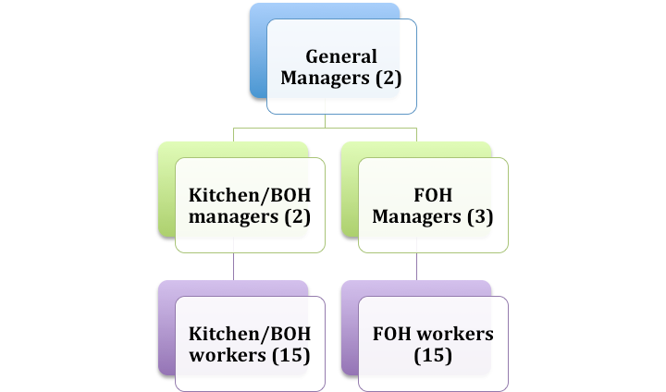

Responsibilities

Owner/ General Managers (2) | -Handle finances for the business  -Hire/fire people  -Handle customer complaints/concerns  - Keep building and food up to codes  -Work other jobs as needed
Kitchen/BOH Manager (2) | -Oversee BOH workers  -Keep orders coming out in timely manner  -Delegate tasks to workers  -Buy food/take inventory  -Help cook when needed
Kitchen Workers (BOH) (15) | -Cook orders  -Bake pastries  -Clean and sanitize kitchen  -Fill Sauces/ Keep inventory stocked in kitchen and make note of what’s needed  -Do dishes
FOH Manager (3) | -Delegate tasks to workers  -Oversee FOH workers  -Make sure orders are being taken correctly  -Talk to customers if they have any issues  -Make sure food in case is displayed appealingly  -Make note of what’s needed
FOH Workers (15) | -Take orders  -Give customers their food  -Handle money transactions  -Keep counters and tables clean  -Brew coffee when it’s low  -Make sure there are silverware and plates

Job Descriptions

BOH Manager: Oversee BOH workers and make sure orders are going out promptly and correctly, delegate tasks to BOH workers during lulls in customers, buy food and take inventory of what’s needed, and help cook when needed. Need to be able to work full time, work flexible hours, have a bachelor’s degree, and 2+ years kitchen experience.

BOH Workers: Cook orders, bake fresh pastries, make in-house sauces, keep kitchen clean and sanitized, fill sauces and keep inventory in the kitchen fully stocked, make note of anything needed. Also will need to do dishes regularly and frequently. Can be full or part time. Prior experience in kitchen is preferred, but not necessary. Must be able to be on feet for long periods of time.

Purchasing

We will be using the informal purchasing format to purchase all of our foods. We will be utilizing local farms, primarily Butterfield Farms, to purchase all of our produce and dairy. We will get weekly quotes on the food we are buying from the farms and we will discuss pricing with them until we decide on a fair price. We will also be using a par stock system for inventory, so we never have to worry about not having enough food on hand at one time. With a par stock system, we will need to decide on a reasonable amount of each product to keep on hand at a time. Whenever our inventory falls below this decided amount, the stock will be replenished to the original amount.

Hiring Process

Our job listing will be posted online to our social media pages (facebook, twitter and our website), job websites, local newspapers, school newspapers, flyers, etc. We will take into consideration the position that needs filling when we are advertising the spot, for example: we wouldn’t advertise an open manager position in a school newspaper. Our application will be available online on our website, along with in person in the bakery. Applicants will fill out an application that they will turn in online or in person, along with a resume.General managers will sort through the applications to find the most qualified people for the open job. General managers bring in applicants for individual interviews. Examples of questions that may be asked:
- Prior experience
- Hours and availability
- Why they want to work at a bakery/what skills they can offer to the operation
We will be seeking help from a variety of people depending upon the spot that needs to be filled. High school or college kids could work as cashiers and cooks, but people being hired as managers will need to be able to offer more time and experience. Applicants deemed fit for the job will be notified promptly within a week after their interviews. New employees will attend an orientation in which they learn how to use all the equipment, what’s expected of them, and they will be walked through how to complete their day-to-day tasks.

Policy and Procedure

Policy
Employees receive a strike every time they arrive late without an appropriate excuse. After three strikes their employment will be terminated.

Procedure
Employees must be clocked in and dressed appropriately for work by the time they are scheduled to begin their shift.

Kitchen Design
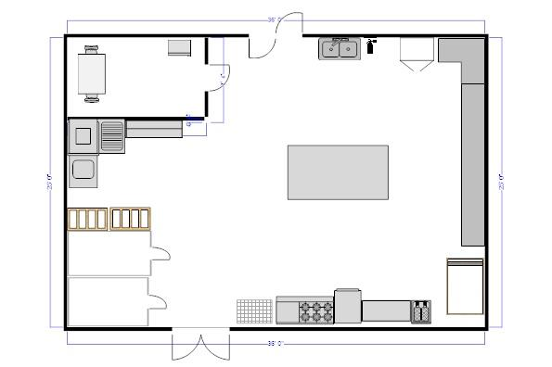
Above is our 900 square foot kitchen design. Starting from the top left of the projected layout, we designed a break room for employees followed by the double doors that lead out to the service area. Next to the doors is the employee hand washing sink, and a fire extinguisher. Then, there is a cabinet for storage, and counter space where various mixers and machines, such as a coffee machine will be fitted. There is also storage available under the countertops. Next, is the dry food storage closet, deep fryers, griddle, double ovens, six burners with an attached skillet and oven underneath, and then a cooling rack. The doors in the back of the kitchen are designated as the receiving doors. The walk-in freezer and refrigerator are bordered by more shelves; the shelves are next to the dishwashing unit, that also has shelving to hold the clean dishes, and store dirty dishes. Since we have 15 employees, we made sure to include adequate walking space, to prevent any confusion or collisions when working in the kitchen area.
Equipment:
Fridge
Freezer
Mixers (2)
Oven (2)
Panini Grill
Grill
Walk in Fridge/Freezer
Pots + Pans
Cookie Sheets
Spoons
Dishwasher
Plates
Baking Dishes
Stove Top
Three Compartment Sink and Hand washing Sites
Coffee Machine
Display Case
Shelving
Roll Out Pins
Cooking Racks
Ingredient Room
Vegetable Preparation
Deep Frier
Sound System

Lighting: Kitchen (30 to 40 light intensity)
Dining area: (40 to 50 light intensity)
Heating/AC: HVAC system- Heating, ventilation, air conditioning, fan system in the kitchen built in a hood placed over oven to eliminate odors, fumes, moisture
Plumbing: Employee restroom
Customer restroom
All pipes going into kitchen should be enclosed and out of site.
Floor Plan: 17 to 20 sq ft per seat
at least five feet wide between seat
**See powerpoint for images of energy-star kitchen products

Serving Sizes and Cost Per Serving
Breakfast Items
Lunch Items
Available All Day
Item Name (GF= Gluten Free) | Serving Size | Cost Per Serving
Plain Bagel | 1 bagel | $1.25
Everything Bagel | 1 bagel | $1.25
Wheat Bagel | 1 bagel | $1.25
Plain Cream Cheese | 4oz | $00.75
Strawberry Cream Cheese | 4 oz | $00.75
Veggie Cream Cheese | 4 oz | $00.75
Blueberry Bagel | 1 bagel | $1.25
Cinnamon Raisin Bagel | 1 bagel | $1.25
Plain GF Bagel | 1 bagel | $2.00
Blueberry GF Bagel | 1 bagel | $2.00
Cinnamon GF Bagel | 1 bagel | $2.00
Blueberry Pie | 1 slice @ 12 slices per pie | $1.83, rounded to $2.00
Apple Pie | 1 slice@ 12 slices per pie | $2.00
Pumpkin Pie | 1 slice @ 12 slices per pie | $2.00
Plain Donut | 1 donut | $1.00
Chocolate Donut | 1 donut | $1.00
Apple Fritter | 1 fritter | $1.25
Cake Donut | 1 donut | $00.75
Chocolate Icing Donut | 1 donut | $1.00
Choc. Icing/ Sprinkles Donut | 1 donut | $1.00
Vanilla Icing Donut | 1 donut | $1.00
Van. Icing/ Sprinkles Donut | 1 donut | $1.00
Blueberry Donut | 1 donut | $1.00
Pistachio Baklava | 1 slice @ 2 slices per Baklava | $3.00
Cannoli | 1 cannoli | $2.50
Éclair | 2 eclairs | $2.25
Cheese Danish | 1 danish | $2.00
Cherry Danish | 1 danish | $2.00
Strawberry Danish | 1 danish | $2.00
Cinnamon Roll | I cinnamon roll | $2.25
Cronut | 1 cronut | $1.75
Chocolate Chip Muffin | 1 muffin | $1.50
Blueberry Muffin | 1 muffin | $1.50
Mixed Seasonal Fruit Salad | 1.5 cups fruit salad | $3.25
Plain Oatmeal | 1.5 cups oatmeal | $1.50
Apple-Almond Oatmeal | 1.5 cups oatmeal | $2.25
Coffee | 12 oz | $1.75
Café Americano | 12 oz | $2.50
Espresso | 6 oz | $2.25
Cappuccino | 8 oz | $2.95
Latte | 12 oz | $2.75
Chai Tea Latte | 12 oz | $2.85
Mocha | 12 oz | $2.95
Orange Juice | 12 oz | $2.95
Apple Juice | 12 oz | $2.95
Almond Milk | 8 oz | $2.00
Soy Milk | 8 oz | $2.00
Skim Milk | 8 oz | $1.50
1% Milk | 8 oz | $1.50
2% Milk | 8 oz | $1.50
Seasonal Fruit Smoothie | 12 oz | $4.50
Whole Wheat Pancake (M) | 3 pancakes@ 3 per stack | $3.50
GF Pancake (M) | 3 pancakes @ 3 per stack | $3.75
Bacon | 3 slices | $2.35
Chef Salad(M) | 12oz bowl | $4.25
Butternut Squash Soup (M) | 1.5 cups | $3.75
Egg (Scrambled) | 1 egg | $1.00
Egg Whites (Scrambled) | 2 egg whites | $1.75
Fried Egg | 1 egg | $1.00
Hard Cooked Egg | 1 egg | $1.00
Omelet (T) | 2 eggs, I cup toppings | $6.75
Three Cheese Panini (T) | 1 panini | $6.85
GF Three Cheese Panini (T) | 1 panini | $6.95
Tomato Basil Soup with Cream | 1.5 cups | $3.75
Parfait (see Wednesday) | 1.5 cups | $3.50
Southwestern Wrap (W) | 1 wrap | $4.75
Chicken Fajita Soup (W) | 1.5 cups | $3.45
Egg Bagel (R) | 1 bagel | $2.75
PB & Jelly (R) | 1 sandwich | $2.25
GF PB & Jelly (R) | 1 sandwich | $2.75
French Onion Soup | 1.5 cups | $3.55
French Toast (F) | 2 slices @ 3 pieces per stack | $1.25
GF French Toast (F) | 2 slices @ 3 slices per stack | $1.40
Apple, Feta, Walnut Salad (F) | 2 cups | $3.85
Chicken Noodle Soup | 1.5 cups | $2.75
Breakfast Sandwich (Sat) | 1 sandwich | $3.00
Chicken Pesto Panini (Sat) | 1 panini | $5.75
Broccoli Cheddar Soup (Sat) | 1 panini | $2.95
Multigrain Waffles (Sun) | 2 large waffles | $2.95
B.L.T.A. (Sun) | 1 sandwich | $4.75
Seasonal Veggie Soup (Sun) | 1.5 cups | $3.25

Meals With Standardized Recipes Quantified for 300 People
Chicken Pesto Panini

Chicken Pesto Panini (Serves 4)

- 16oz chicken tenders
- ½ c Pesto
- ½ c Mayonnaise
- 1 -16oz Ciabatta Loaf
- 4 slices Mozzarella
- 1 c Baby Spinach
- 15 fresh Basil leaves
- 2 Tomatoes, sliced

Directions:
Using a plastic bag, combine the chicken and ¼ c pesto, let sit for 15 minutes. Combine the other ¼ c pesto with the mayonnaise. Cut the ciabatta loaf in half, and spread the mixture on both sides. Preheat a grill, then cook the chicken tenders for five minutes on each side. After the chicken is cooked, Place cheese, spinach, and tomatoes on both halves of the bread. Put the cooked chicken in the middle. Grill the sandwich for three minutes on each side over medium heat, or until the cheese starts to melt. Cut into 4 portions, serve and enjoy!

Chicken Pesto Panini (Serves 300)

- 1200 oz, (75 lbs) chicken tenders
- 18.75 c Pesto
- 18.75 c Mayonnaise
- 75 - 16oz Ciabatta Loaf
- 75 c Baby Spinach
- 1125 fresh Basil leaves
- 150 Tomatoes, sliced

Meals With Standardized Recipes Quantified for 300 People
Broccoli Cheddar Soup

Broccoli Cheddar Soup (Serves 3)

- 3 c Vegetable Stock
- 2 c Broccoli Florets
- 1 c diced White Onion
- 1 15 oz can Evaporated Milk
- 2 c Sharp Cheddar Cheese

Directions:
In a medium saucepan, stir together stock, diced onion and broccoli. Heat over high heat until a low boil. Reduce heat to medium and continue boiling for about 5 minutes, or until the onions are tender. Stir in the evaporated milk and continue cooking for 3 minutes or until the mixture returns to a simmer. Remove from heat and stir in the cheese until melted. Serve, and enjoy!

Broccoli Cheddar Soup (Serves 300)

- 100 c (25 qt) Vegetable Stock
- 150 c (1200 oz) Broccoli Florets
- 100 c diced White Onion
- 100 15 oz can Evaporated Milk
- 150c (1200 oz) Sharp Cheddar Cheese

Nutrition Analysis/Weekly Nutrition Report
Buddy, 5’ 11”
220 pounds
Sedentary, Maintain Weight

Calories Per Day: 2800

Macronutrient Breakdown:
Carbohydrate: 50% = 350g/day
Protein: 30% = 210 g/day
Fat: 20% = 62 g/day
Monday
Breakfast: 12 oz Coffee, Everything Bagel, 4 oz Cream Cheese, Fruit Salad
Lunch: Chef Salad with Ranch Dressing, Butternut Squash Soup, 12 oz Apple Juice
1120/2800 Calories consumed

Tuesday
Breakfast: Omelet, Apple-Almond Oatmeal, Cafe Americano
Lunch: Three Cheese Panini, Tomato Basil Soup, 12 oz Orange Juice
1372/2800 Calories consumed

Wednesday
Breakfast : Greek Yogurt Parfait, Cappuccino, Glazed Donut
Lunch: Southwestern Wrap, Chicken Fajita Soup, 8 oz Skim Milk
1407/2800 Calories consumed

Thursday
Breakfast : Egg Bagel, Latte, Fruit Danish
Lunch : Peanut Butter and Jelly Sandwich, French Onion Soup, Almond Milk 8 oz
1984/2800 Calories consumed

Friday
Breakfast: French Toast with Honey and Strawberries, Soy Milk, 8oz
Lunch : Apple, Feta, and Walnut Salad with Chicken, Chicken Noodle Soup, Chai Tea Latte
1025/2800 Calories consumed

Saturday
Breakfast : Breakfast Sandwich on an English Muffin, 2% Milk 8 oz
Lunch : Chicken Pesto Panini, Broccoli Cheddar Soup, Fruit Smoothie
1760/2800 Calories consumed

Sunday
Breakfast: Multigrain Waffles and Fruit, Mocha Latte
Lunch : B.L.T.A, Vegetable Soup, Cinnamon Roll, espresso, 6 oz, 1% milk 8 oz
1260/2800 Calories Consumed

Weekly Nutrition Analysis, Supertracker, Based off of a 2800 Daily Calorie Allowance

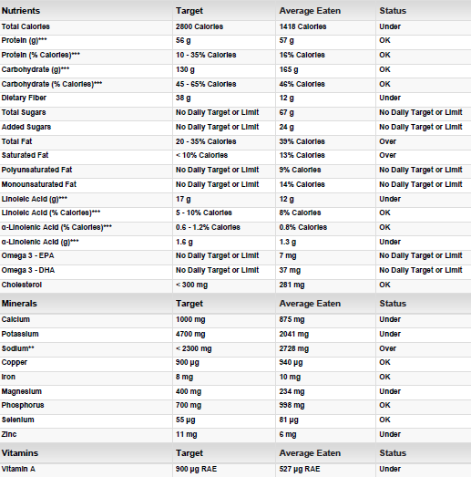
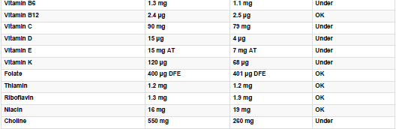
** Our analysis only reflects two meals per day, we recognize that this may cause our daily allowances to appear skewed, along with the amount of calories consumed per day.
Dietary Information Obtained From: Supertracker.USDA.gov

Training Module

Our training module is a video on youtube of how to properly conduct an interview.

References

"Automated Software for Flowcharts, Org Charts, Floor Plans and More." SmartDraw. N.p., n.d. Web. 20 Nov. 2014.

“Butterfield Farm Market.” Butterfield Farm Market. Web. 23 Nov. 2014. http://www.butterfieldfarmmarket.com/home.html

How to Start a Bakery - The Ultimate Source For Starting a Bakery. (n.d.). Retrieved November 25, 2014, from http://www.starting-a-bakery.com

“Make a Commercial Building More Sustainable.” Wellington.gov. Web. 20 Nov. 2014
http://www.sustainablecapitolhill.org/top-10-ways-to-make-your-building-greener.html

Payne-Palacio, June, and Monica Theis. Foodservice Management: Principles and Practices. Boston: Prentice Hall, 2012. Print.

"SuperTracker." ChooseMyPlate.gov. USDA, n.d. Web. 1 Nov. 2014.

